Opportunity to Acquire a Fully Developed Investment Concept
and Its Intellectual Property
Al Salam in Al Sham Project … or … Orient Star Project

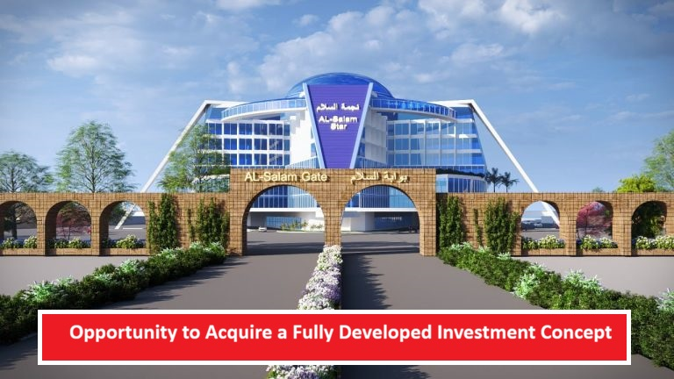

Al Salam in Al Sham, also known as the Orient Star Project, is an innovative urban, tourism, and cultural development concept currently in the development stage. It aims to create a unique destination that combines architectural symbolism, tourism appeal, and cultural value within a comprehensive future-oriented vision.
The project is based on a collection of symbolic and landmark facilities designed to form a distinctive identity with the potential to evolve into a large-scale investment destination capable of attracting visitors, investors, and strategic partners from around the world.
The offering includes the complete acquisition of the project's intellectual property rights, preliminary engineering designs, initial project study, website, and all related assets and documentation. This enables the investor or strategic partner to move directly into advanced development and future implementation phases.

Assets Available for Acquisition
✅ Original Project Concept
✅ Comprehensive Investment and Strategic Vision
✅ Preliminary Studies and Research
✅ Conceptual Engineering Plans and Designs
✅ Trademarks and Commercial Naming Rights
✅ Marketing and Promotional Content
✅ Project Website
✅ Future Development and Investment Rights
✅ All Digital Files and Supporting Documentation

Why Acquire This Project
Rather than starting from scratch and investing years in developing the concept, visual identity, master planning, and preliminary studies, an investor can acquire a well-developed intellectual and planning foundation that is ready for further advancement.
This allows the new owner to focus directly on detailed feasibility studies, securing partnerships, attracting financing, and progressing toward executive design and implementation according to their own investment strategy.

Current Development Status
The project is currently in the conceptual development phase and includes:
• A comprehensive and clearly defined strategic vision.
• Preliminary engineering plans and conceptual designs.
• An initial project study.
• A dedicated project website.
• Intellectual property assets available for transfer or licensing.
• A complete promotional and presentation package supporting investment discussions.
No construction or physical development has commenced to date.

Investment and Acquisition Options
Option 1
Full acquisition of the project and all associated intellectual property and development rights.
Option 2
Acquisition of a partial ownership interest in the project and its assets.
Option 3
Exclusive or non-exclusive licensing of the concept and its related intellectual property.
Option 4
Strategic partnership for project development and implementation.
Option 5
Participation as a lead investor or strategic development partner.

Invitation to Investors and Strategic Partners
Al Salam in Al Sham, or the Orient Star Project, represents a rare opportunity to acquire a distinctive urban, tourism, and cultural concept with a unique identity and significant development potential.
The project provides investors with the opportunity to build upon an established intellectual, engineering, and marketing foundation, reducing the time and effort required to transform an ambitious vision into a landmark destination with long-term economic, cultural, and strategic value.

https://orient-star.net

